GREATER CAIRO METRO
LINE No.3 (Thawra Line)
TCMS-EBCU interface specification

Approved by | 18.Mar.2019 | K.K. SHIN | 
Reviewed by | 18.Mar.2019 | S.J. SEO | 
Written by | 18.Mar.2019 | H.KIM | 
 | Date | Name | Signature

Revision History
Issue | Page | Revision |  | Date
Issue | Page | Contents | Reference | Date
0 | All | First issue |  | 18.Mar.2019

Contents
1. INTRODUCTION 4
1.1. LIST OF ABBREVIATIONS 4
2. GENERAL 5
2.1. MVB Specification 5
2.2. MVB Connection 6
2.3. MVB Telegram 7
2.4. Train Formation of Cairo3 8
3. DATA EXCHANGE 10
3.1. TCMS → EBCU PBC (Powering & Braking Command) 10
3.1.1. TCMS_VVVF_EBCU_PBC 10
3.2. TCMS → EBCU SDR (Status Data Request) 11
3.2.1. TCMS-EBCU-SDR1 11
3.2.2. TCMS-EBCU-SDR2 12
3.2.3. TCMS-EBCU-SDR3 13
3.3. EBCU → TCMS SD(Status Data) 15
3.3.1. EBCUx-TCMS-SD 15
3.4. EBCU → VVVF Blending 18
3.4.1. EBCUx-VVVFy-Blending 18
3.5. VVVF → EBCU Blending 18
3.5.1. VVVFx-EBCUy-Blending 19

INTRODUCTION
This document describes the interface specification between TCMS(Data Bus System) and EBCU(Electronic Brake Control Unit) for GREATER CAIRO METRO LINE No.3 (Thawra Line) project.

LIST OF ABBREVIATIONS
TCN Train Control Network
MVB Multifunction Vehicle Bus
EMD Electrical Medium Distance
WTB Wire Train Bus
TCMS Train Control and Monitoring System
CCU Central Control Unit
VCU Vehicle Control Unit
IO-M remote IO Module
VVVF Variable Voltage Variable Frequency
DU Display Unit
RTD Remote Transmission Device
DCU Door Control Unit
ATP Automatic Train Protection
EBCU Electrical Brake Control Unit
VAC Ventilation Air conditioner Controller
TCU Traction Control Unit
APU Auxiliary Power Unit
EVR Event Recorder
HCR Header Car Relay
MF Major Fault
MCF Major Complementary Fault
HSCB High Speed Circuit Breaker
LB Line Bus Switch
PB Parking Brake
EB Emergency Brake
HB Holding Brake
FSB Full Service Brake
AUTO Automatic Mode
ADB All Door Bypass
ADC All Door Closed
AAU Automatic Announcement Unit
DCU Display Control Unit(for PA/PIS)
BC Battery Charger
HCR Head Control Relay
SDR Status Data Request
SD Status Data

GENERAL
TCMS and EBCU are interfaced with MVB. This document describes interface between TCMS and EBCU through MVB.

MVB Specification
General specification of MVB is described as follow.
-. Redundancy : Line A, Line B
-. Master / Slave : TCMS is only Master.
The subsystem needs not to act as bus administrator.
-. Media Support : EMD(Electrical Middle Distance) Communication Distance within 200m
<Table 1 Summary of the Multifunction Vehicle Bus by IEC 61375-1>
topology | bus(electrical)  star(optical)
Media | Electrical Short Distance  Electrical Middle Distance  Optical Glass Fibre | twisted wire pair, biased RS-485  shielded twisted wire pair, transformer coupled  200/240 µm fibres and star coupler
Length | Electrical Short Distance  Electrical Middle Distance  Optical Glass Fibre | 20 m, 32 devices per segment  200 m, 32 devices per segment  2000 m
Physical Redundancy | duplicated physical medium(synchronous send)
Signalling | Manchester II, 9-bit frame Start Delimiter
Signalling rate | 1.5 Mbit/s
Address space | 12-bit Device Address  (0…255 reserved for devices with Message Data capability)  12-bit Logical Address for Process Data  (each 16…256 bits)
Physical Addressing | single cast and broadcast
Frame size  (useful data) | 16, 32, 64, 128, 256 bits
Integrity | CRC-8 per 64bits + Manchester encoding, different frame Start Delimiter for Master Frame and Slave Frame against synchronization slip, reception time window supervision
Medium Allocation | by one centralized Master(Hyundai-Rotem’s CCU & VCU)
Traffic | periodic(mainly for Process Data)  sporadic(mainly for Message Data)  supervisory(for Supervisory Data)
Mastership Transfer | mastership transfer by token passing  serveral Bus Administrators can become Master in turn
Mastership Redundancy  (Option) | redundant Bus Administrators serve as back-up
Link Layer Service | Link Process Data Interface  Link Message Data Interface  Link Supervision Interface |  | broadcast of source addressed data  datagrams  Link Layer Management

MVB Connection
Where interchangeability is required, Subsystems connected by MVB shall be attached to the cable as follow:
<Table 2 Pin assignment for the EMD Connector>
1 | A.Data_P positive wire of Line A | 6 | A.Term_P, Positive pole of Terminator Line A
2 | A.Data_N negative wire of Line A | 7 | A.Term_N, Negative pole of Terminator Line A
3 | Not Used | 8 | B.Term_P, Positive pole of Terminator Line B
4 | B.Data_P positive wire of Line B | 9 | B.Term_N, Negative pole of Terminator Line B
5 | B.Data_N negative wire of Line B
Note 1 It is recommend to arrange the two connectors side by side on a device, Connector 1 on the left and Connector 2 on the right, to thread the wiring neatly.
Note 2 It may be necessary to ensure that the connector case is isolated from the device case if connection of the device cases is not advisable, for instance when large stray currents are expected.
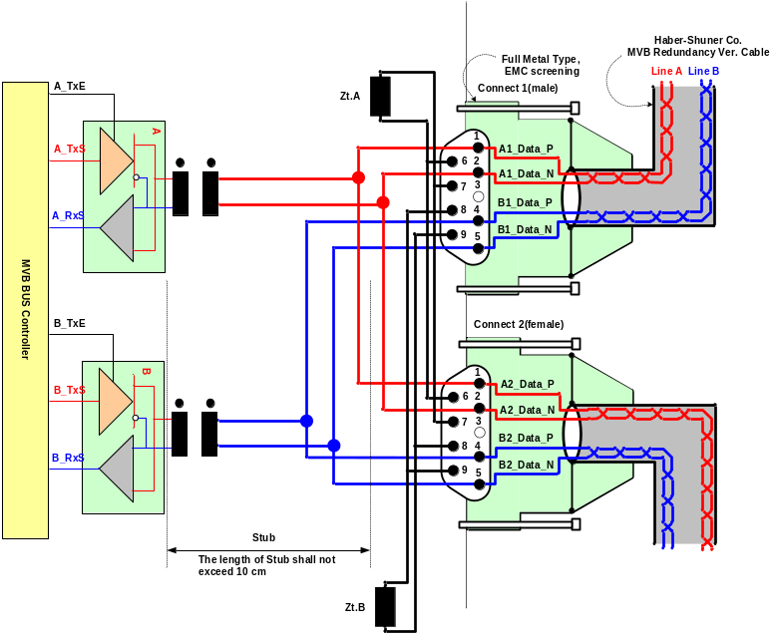
Figure 1 Double line EMD connector arrangement

MVB Telegram
There are 16 telegrams types on the MVB, which are distinguished by the F-code in Master Frame, as shown in Table 3.
Table 3 F-code of the MVB(Master Frame Type)

F-Code | Telegram Type
0 | Process Data Request with 16 bits
1 | Process Data Request with 32 bits
2 | Process Data Request with 64 bits
3 | Process Data Request with 128 bits
4 | Process Data Request with 256 bits
5 | (reserved)
6 | (reserved)
7 | (reserved)
8 | Mastership Transfer Request
9 | General Event Request
10 | (reserved)
11 | (reserved)
12 | Message Data Request
13 | Group Event Request
14 | Single Event Request
15 | Device Status Request
The basic data type for MVB network between TCMS and sub-system is WORD. Physical address is not used.
The byte ordering is the Big-Endian(Motorola) but, all data is read like word. So, the subsystem side must change like example.
The byte order and bit order for a data are as follows.
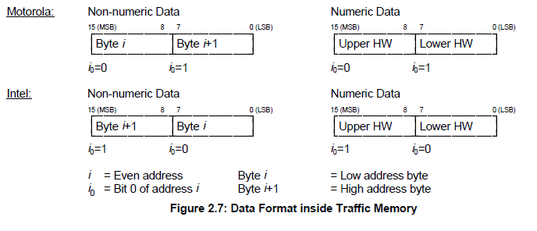
- MVB supervision :
The CCU is indicating the MVB state by the MVB watchdog counter that increases when the application is executed.
The counter from the MVB device is generated as soon as the application software is ready. If no MVB connection is established, i.e.
The MVB watchdog counter can not be received or an internal fault in the MVB device occurs, the signals, besides the watchdog counter, shall be had default value.
<Bit Ordering>
Data structures shall be numbered from left to right and from top to bottom, in the order of reading an English text. The first item on the top and to the left has offset zero.
WORD | Data Contents |  |  |  |  |  |  |  | Remark
WORD | Bit Mask |  |  |  |  |  |  |  | Remark
WORD | 15 | 14 | 13 | 12 | 11 | 10 | 9 | 8
WORD | 7 | 6 | 5 | 4 | 3 | 2 | 1 | 0
0 | 0 | 1 | 2 | 3 | 4 | 5 | 6 | 7
0 | 8 | 9 | 10 | 11 | 12 | 13 | 14 | 15
1 | 16 | 17 | 18 | 19 | 20 | 21 | 22 | 23
1 | 24 | 25 | 26 | 27 | 28 | 29 | 30 | 31
2 | 32 | 33 | 34 | 35 | 36 | 37 | 38 | 39
2 | 40 | 41 | 42 | 43 | 44 | 45 | 46 | 47
3 | 48 | 49 | 50 | 51 | 52 | 53 | 54 | 55
3 | 56 | 57 | 58 | 59 | 60 | 61 | 62 | 63
4 | 64 | 65 | 66 | 67 | 68 | 69 | 70 | 71
4 | 72 | 73 | 74 | 75 | 76 | 77 | 78 | 79
5 | 80 | 81 | 82 | 83 | 84 | 85 | 86 | 87
5 | 88 | 89 | 90 | 91 | 92 | 93 | 94 | 95
6 | 96 | 97 | 98 | 99 | 100 | 101 | 102 | 103
6 | 104 | 105 | 106 | 107 | 108 | 109 | 110 | 111
7 | 112 | 113 | 114 | 115 | 116 | 117 | 118 | 119
7 | 120 | 121 | 122 | 123 | 124 | 125 | 126 | 127
8 | 128 | 129 | 130 | 131 | 132 | 133 | 134 | 135
8 | 136 | 137 | 138 | 139 | 140 | 141 | 142 | 143
9 | 144 | 145 | 146 | 147 | 148 | 149 | 150 | 151
9 | 152 | 153 | 154 | 155 | 156 | 157 | 158 | 159
10 | 160 | 161 | 162 | 163 | 164 | 165 | 166 | 167
10 | 168 | 169 | 170 | 171 | 172 | 173 | 174 | 175
11 | 176 | 177 | 178 | 179 | 180 | 181 | 182 | 183
11 | 184 | 185 | 186 | 187 | 188 | 189 | 190 | 191
12 | 192 | 193 | 194 | 195 | 196 | 197 | 198 | 199
12 | 200 | 201 | 202 | 203 | 204 | 205 | 206 | 207
13 | 208 | 209 | 210 | 211 | 212 | 213 | 214 | 215
13 | 216 | 217 | 218 | 219 | 220 | 221 | 222 | 223
14 | 224 | 225 | 226 | 227 | 228 | 229 | 230 | 231
14 | 232 | 233 | 234 | 235 | 236 | 237 | 238 | 239
15 | 240 | 241 | 242 | 243 | 244 | 245 | 246 | 247
15 | 248 | 249 | 250 | 251 | 252 | 253 | 254 | 255

Train Formation of Cairo3
The train formation consists of 8 cars and can be seen in following figure. The detail arrangement is DTC-MC1-MC2-MCI-MCI-MC2-MC1-DTC. The two CCUs(Central Control Unit) are installed in both DTC, two VCUs are installed in MCI and two IO-Ms are installed in MC. CCU and VCU(Vehicle Control Unit) is connected to subsystem via MVB(Multifunction Vehicle Bus), WTB(Wire Train Bus) is used by the data communication interface between CCU and VCU.

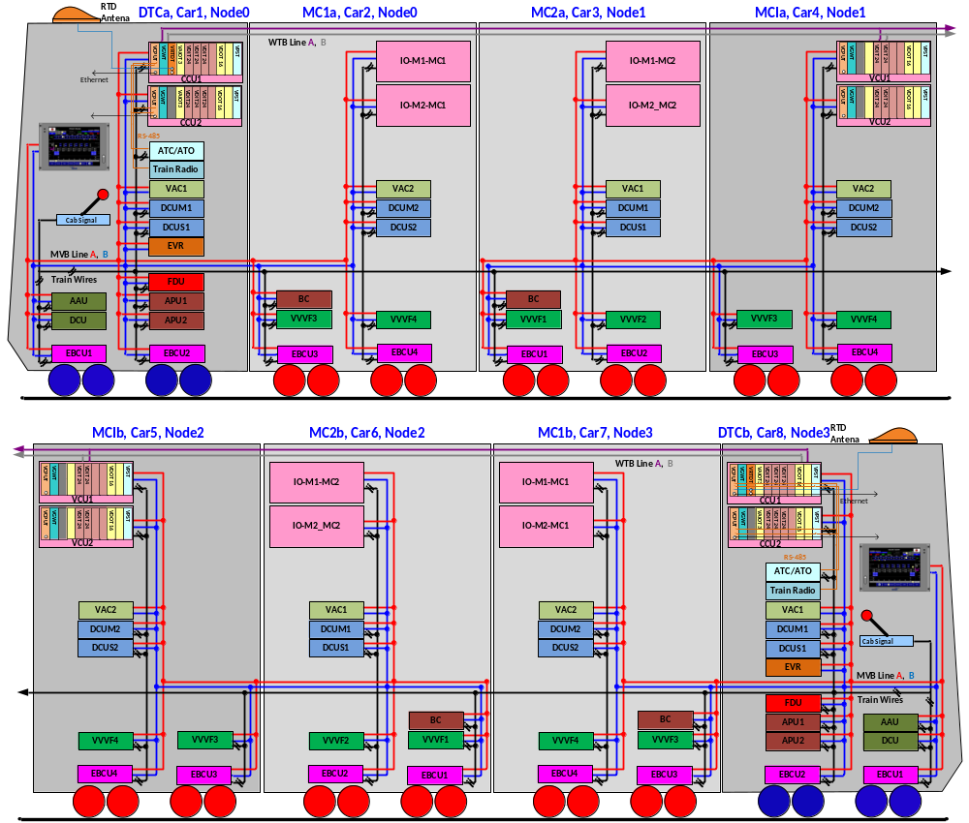

Figure 2 Configuration

DATA EXCHANGE

TCMS → EBCU PBC (Powering & Braking Command)
Telegram name | Source | Sink | Port address | Fcode | Task | Remark
TCMS_VVVF_EBCU_PBC | TCMS | EBCU ALL  VVVF ALL | 18H | 2

TCMS_VVVF_EBCU_PBC
WORD | Data Contents |  |  |  |  |  |  |  | Remark
WORD | Bit Mask |  |  |  |  |  |  |  | Remark
WORD | 15 | 14 | 13 | 12 | 11 | 10 | 9 | 8
WORD | 7 | 6 | 5 | 4 | 3 | 2 | 1 | 0
0 | ADC | EDCut |  |  |  | FullServiceBrake | ParkingBrake | EmergnecyBrake
0 | HoldingBrakeReset |  |  | ATOMode | Forward | Reverse | PoweringMode | BrakingMode
1 | PoweringDemand(0.1 %/bit resolution)
2 | BrakeDemand(0.1 %/bit resolution)
3 | WatchDogCounterPBC

Bit  Offset | Data  Size | Data  Type | Data Name | Contents | Remarks
0 | 1 | BOOL | ADC | All Door Closed(=1)
1 | 1 | BOOL | EDCut | EDCut(=1) | For VVVF
2 | 1 | BOOL
3 | 1 | BOOL | -
4 | 1 | BOOL | -
5 | 1 | BOOL | FullServiceBrake | Full Service Brake(=1)
6 | 1 | BOOL | ParkingBrake | Parking Brake(=1)
7 | 1 | BOOL | EmergnecyBrake | Emergnecy Brake(=1)
8 | 1 | BOOL | HoldingBrakeReset | Holding Brake Reset Command (“1” for 1 sec) | For EBCU
9 | 1 | BOOL
10 | 1 | BOOL
11 | 1 | BOOL | ATOMode
12 | 1 | BOOL | Forward | Motor Direction(1=Forward) | For VVVF
13 | 1 | BOOL | Reverse | Motor Direction(1=Reverse) | For VVVF
14 | 1 | BOOL | PoweringMode | 1 = Traction
15 | 1 | BOOL | BrakingMode | 1 = Braking
16 | 16 | UNSIGNED16 | PoweringDemand | 0.1 %/bit resolution
32 | 16 | UNSIGNED16 | BrakeDemand | 0.1 %/bit resolution
48 | 16 | UNSIGNED16 | WatchDogCounter | updated every 64 ms  When watchdog counter stop, brake System must be controlled by powering mode and brake mode of hardwire

TCMS → EBCU SDR (Status Data Request)
Telegram name | Source | Sink | Port address | Fcode | Task | Remark
TCMS-EBCU-SDR1 | TCMS | EBCU ALL | 0x28 | 4
TCMS-EBCU-SDR2 | TCMS | EBCU ALL | 0x38 | 4
TCMS-EBCU-SDR3 | TCMS | EBCU ALL | 0x48 | 4

TCMS-EBCU-SDR1
WORD | Data Contents |  |  |  |  |  |  |  | Remark
WORD | Bit Mask |  |  |  |  |  |  |  | Remark
WORD | 15 | 14 | 13 | 12 | 11 | 10 | 9 | 8
WORD | 7 | 6 | 5 | 4 | 3 | 2 | 1 | 0
0 | WatchDogCounterTCMS
1 | DateTimeYear
1 | DateTimeMonth
2 | DateTimeDay
2 | DateTimeHour
3 | DateTimeMinute
3 | DateTimeSec
4 | DateTimeValid |  |  |  | MVB_Node3(car7/8) | MVB_Node2(car5/6) | MVB_Node1(car3/4) | MVB_Node0(car1/2)
5 |  |  | MC1a_VVVF3_FadeOut | MC1a_VVVF4_FadeOut | MC2a_VVVF1_FadeOut | MC2a_VVVF2_FadeOut | MCIa_VVVF3_FadeOut | MCIa_VVVF4_FadeOut | Unit A
5 |  |  | MC1b_VVVF3_FadeOut | MC1b_VVVF4_FadeOut | MC2b_VVVF1_FadeOut | MC2b_VVVF2_FadeOut | MCIb_VVVF3_FadeOut | MCIb_VVVF4_FadeOut | Unit B
6 |  |  | MC1a_VVVF3_OK | MC1a_VVVF4_OK | MC2a_VVVF1_OK | MC2a_VVVF2_OK | MCIa_VVVF3_OK | MCIa_VVVF4_OK | Unit A
6 |  |  | MC1b_VVVF3_OK | MC1b_VVVF4_OK | MC2b_VVVF1_OK | MC2b_VVVF2_OK | MCIb_VVVF3_OK | MCIb_VVVF4_OK | Unit B
7 |  |  | MC1a_VVVF3_EDBOK | MC1a_VVVF4_ EDBOK | MC2a_VVVF1_ EDBOK | MC2a_VVVF2_ EDBOK | MCIa_VVVF3_ EDBOK | MCIa_VVVF4_ EDBOK | Unit A
7 |  |  | MC1b_VVVF3_EDBOK | MC1b_VVVF4_ EDBOK | MC2b_VVVF1_ EDBOK | MC2b_VVVF2_ EDBOK | MCIb_VVVF3_ EDBOK | MCIb_VVVF4_ EDBOK | Unit B
8 | DTCa_EBCU1_OK | DTCa_EBCU2_OK | MC1a_ EBCU3_OK | MC1a_ EBCU4_OK | MC2a_ EBCU1_OK | MC2a_ EBCU2_OK | MCIa_ EBCU3_OK | MCIa_ EBCU4_OK | Unit A
8 | DTCb_EBCU1_OK | DTCb_EBCU2_OK | MC1b_ EBCU3_OK | MC1b_ EBCU4_OK | MC2b_ EBCU1_OK | MC2b_ EBCU2_OK | MCIb_ EBCU3_OK | MCIb_ EBCU4_OK | Unit B
9 | DTCa_EBCU1_BrakeForceLimit | DTCa_EBCU2_BrakeForceLimit | MC1a_ EBCU3_BrakeForceLimit | MC1a_ EBCU4_BrakeForceLimit | MC2a_ EBCU1_BrakeForceLimit | MC2a_ EBCU2_BrakeForceLimit | MCIa_ EBCU3_BrakeForceLimit | MCIa_ EBCU4_BrakeForceLimit | Unit A
9 | DTCb_EBCU1_BrakeForceLimit | DTCb_EBCU2_BrakeForceLimit | MC1b_ EBCU3_BrakeForceLimit | MC1b_ EBCU4_BrakeForceLimit | MC2b_ EBCU1_BrakeForceLimit | MC2b_ EBCU2_BrakeForceLimit | MCIb_ EBCU3_BrakeForceLimit | MCIb_ EBCU4_BrakeForceLimit | Unit B
10
11
12
13
14
15

Bit  Offset | Data  Size | Data  Type | Data Name | Contents | Remarks
0 | 16 | UNSIGNED16 | TWatchDogCounterTCMS
16 | 8 | UNSIGNED8 | DateTimeYear | Year (00 – 99), | BCD
24 | 8 | UNSIGNED8 | DateTimeMonth | Month (1 – 12) | BCD
32 | 8 | UNSIGNED8 | DateTimeDay | Day (1 – 31) | BCD
24 | 8 | UNSIGNED8 | DateTimeHour | Hour (0 -23) | BCD
32 | 8 | UNSIGNED8 | DateTimeMinute | Minute (0 – 59) | BCD
40 | 8 | UNSIGNED8 | DateTimeSec | Second (0 – 59) | BCD
48 | 1 | BOOL | DateTimeValid | 0/1, 1 = Date & Time Validation

TCMS-EBCU-SDR2
WORD | Data Contents |  |  |  |  |  |  |  | Remark
WORD | Bit Mask |  |  |  |  |  |  |  | Remark
WORD | 15 | 14 | 13 | 12 | 11 | 10 | 9 | 8
WORD | 7 | 6 | 5 | 4 | 3 | 2 | 1 | 0
0 | MC1a_VVVF3_BEA (0 – 80KN / 0x0000 – 0x1F40, 0.01kN/bit)
1 | MC1a_VVVF4_BEA (0 – 80KN / 0x0000 – 0x1F40, 0.01kN/bit)
2 | MC2a_VVVF1_BEA (0 – 80KN / 0x0000 – 0x1F40, 0.01kN/bit)
3 | MC2a_VVVF2_BEA (0 – 80KN / 0x0000 – 0x1F40, 0.01kN/bit)
4 | MCIa_VVVF3_BEA (0 – 80KN / 0x0000 – 0x1F40, 0.01kN/bit)
5 | MCIa_VVVF4_BEA (0 – 80KN / 0x0000 – 0x1F40, 0.01kN/bit)
6 | MC1b_VVVF3_BEA (0 – 80KN / 0x0000 – 0x1F40, 0.01kN/bit)
7 | MC1b_VVVF4_BEA (0 – 80KN / 0x0000 – 0x1F40, 0.01kN/bit)
8 | MC2b_VVVF1_BEA (0 – 80KN / 0x0000 – 0x1F40, 0.01kN/bit)
9 | MC2b_VVVF2_BEA (0 – 80KN / 0x0000 – 0x1F40, 0.01kN/bit)
10 | MCIb_VVVF3_BEA (0 – 80KN / 0x0000 – 0x1F40, 0.01kN/bit)
11 | MCIb_VVVF4_BEA (0 – 80KN / 0x0000 – 0x1F40, 0.01kN/bit)
12 | TTW(Total Train Weight) (0 – 655TON / 0x0000 – 0xFFFF, 0.01Ton/bit,)
13
14
15

Bit  Offset | Data  Size | Data  Type | Data Name | Contents | Remarks

TCMS-EBCU-SDR3
WORD | Data Contents |  |  |  |  |  |  |  | Remark
WORD | Bit Mask |  |  |  |  |  |  |  | Remark
WORD | 15 | 14 | 13 | 12 | 11 | 10 | 9 | 8
WORD | 7 | 6 | 5 | 4 | 3 | 2 | 1 | 0
0 | DTCa_EBCU1_FBR(0 – 80KN / 0x0000 – 0x1F40, 0.01kN/bit)
1 | DTCa_EBCU2_FBR(0 – 80KN / 0x0000 – 0x1F40, 0.01kN/bit)
2 | MC1a_EBCU3_FBR(0 – 80KN / 0x0000 – 0x1F40, 0.01kN/bit)
3 | MC1a_EBCU4_FBR(0 – 80KN / 0x0000 – 0x1F40, 0.01kN/bit)
4 | MC2a_EBCU1_FBR(0 – 80KN / 0x0000 – 0x1F40, 0.01kN/bit)
5 | MC2a _EBCU2_FBR(0 – 80KN / 0x0000 – 0x1F40, 0.01kN/bit)
6 | MCIa_EBCU3_FBR(0 – 80KN / 0x0000 – 0x1F40, 0.01kN/bit)
7 | MCIa_EBCU4_FBR(0 – 80KN / 0x0000 – 0x1F40, 0.01kN/bit)
8 | DTCb_EBCU1_FBR(0 – 80KN / 0x0000 – 0x1F40, 0.01kN/bit)
9 | DTCb_EBCU2_FBR(0 – 80KN / 0x0000 – 0x1F40, 0.01kN/bit)
10 | MC1b_EBCU3_FBR(0 – 80KN / 0x0000 – 0x1F40, 0.01kN/bit)
11 | MC1b_EBCU4_FBR(0 – 80KN / 0x0000 – 0x1F40, 0.01kN/bit)
12 | MC2b_EBCU1_FBR(0 – 80KN / 0x0000 – 0x1F40, 0.01kN/bit)
13 | MC2b_EBCU2_FBR(0 – 80KN / 0x0000 – 0x1F40, 0.01kN/bit)
14 | MCIb_EBCU3_FBR(0 – 80KN / 0x0000 – 0x1F40, 0.01kN/bit)
15 | MCIb_EBCU4_FBR(0 – 80KN / 0x0000 – 0x1F40, 0.01kN/bit)

Bit  Offset | Data  Size | Data  Type | Data Name | Contents | Remarks

EBCU → TCMS SD(Status Data)
Telegram name | Source | Sink | Port address | Fcode | Task | Remark
EBCU1-TCMS-SD | EBCU1 | TCMS | 10H | 4
EBCU2-TCMS-SD | EBCU2 | TCMS | 20H | 4
EBCU3-TCMS-SD | EBCU3 | TCMS | 30H | 4
EBCU4-TCMS-SD | EBCU4 | TCMS | 40H | 4

EBCUx-TCMS-SD
WORD | Data Contents |  |  |  |  |  |  |  | Remark
WORD | Bit Mask |  |  |  |  |  |  |  | Remark
WORD | 15 | 14 | 13 | 12 | 11 | 10 | 9 | 8
WORD | 7 | 6 | 5 | 4 | 3 | 2 | 1 | 0
0 | EBCU_WatchdogCounter(0~65535)
1 | AS pressure(0 – 1,000kPa / 0x00 – 0xFA, 4kPa/bit)
1 | BC pressure(0 – 1,000kPa / 0x00 – 0xFA, 4kPa/bit)
2 | SR pressure(0 – 1,000kPa / 0x00 – 0xFA, 4kPa/bit) |  |  |  |  |  |  |  | EBCU 1,3 Only
2 | AC pressure(0 – 1,000kPa / 0x00 – 0xFA, 4kPa/bit)
3 | Axle Speed1 (0~127km/h//00H~FDH, 0.5KPH/bit )
3 | Axle Speed2 (0~127km/h//00H~FDH, 0.5KPH/bit )
4 | Axle Speed3 (0~127km/h//00H~FDH, 0.5KPH/bit )
4 | Axle Speed4 (0~127km/h//00H~FDH, 0.5KPH/bit )
5
5 | Standard Speed (0~127km/h//00H~FDH, 0.5KPH/bit)
6 | LW (Load Weight, 0 – 80TON / 0x0000 – 0x1F40, 0.01Ton/bit)
7 | FBR (Friction Brake Request, 0 – 80KN / 0x0000 – 0x1F40, 0.01kN/bit)
8 | BED (Electrical Brake Request, 0 – 80KN / 0x0000 – 0x1F40, 0.01kN/bit)
9 | BEA (Electrical Brake Achieved, 0 – 80KN / 0x0000 – 0x1F40, 0.01kN/bit)
10 | BECU_F_N |  |  | EO | SCB | B | P | EB | Wire  Status
10 | PS-BC |  | CC-SR | CC-SBR | CC-PB | CC-SR Bogie | CC-AS Bogie | CC-BC Bogie | Wire  Status
11 | ED-CUT  (TCMS) | ADC | ATO | TCMS_B | TCMS_P | TCMS_HBR | TCMS_FSB | TCMS_EB | External  Status
11 | WSD_TCU | MCV | FO | BCV | ED-OK | TCU_HB |  |  | External  Status
12 |  |  |  |  |  |  |  |  | Internal  Status
12 | WSD_BECU | BR | HB | BFL |  |  |  |  | Internal  Status
13 | BECU_FLT | WSP_FLT |  |  |  | AS-PUNK | NRBD_N  ISBD | NRBD | Fault data
13 | SBCOM_FLT | WSPCOM_FLT | TCUCOM_FLT |  | DIAG_FLT | BDFLT_IF | BDFLT_SB | BDFLT_WSP  DIAG_FLT | Fault data
14 | ASV_FLT | SBV_ FLT |  |  | SRP_FLT | ACP_ FLT | BCP_ FLT | ASP_FLT | Fault data
14 |  |  |  |  | AXLE4_ FLT | AXLE3_ FLT | AXLE2_ FLT | AXLE1_ FLT | Fault data
15
15 | RVER(Software Version, 0 ~ 255)

Bit  Offset | Data  Size | Data  Type | Data Name | Contents | Remarks
0 | 8 | UNSIGNED8 | EBCU_WatchdogCounter | -. Range: 0 to 255 (00h to FFh)  -. EBCU increments this bit every transmission cycle. TCMS ignores the information of SD if this counter is not incremented for more than "1000ms".
16 | 8 | UNSIGNED8 | AS Pressure | -. Brake Cylinder Pressure Car  -. Range : 0 – 1,000kPa/0x00 – 0xFA, 4kPa/bit
24 | 8 | UNSIGNED8 | BC Pressure | -. Brake Cylinder Pressure Car  -. Range : 0 – 1,000kPa/0x00 – 0xFA, 4kPa/bit
32 | 8 | UNSIGNED8 | SR Pressure | -. Reservoir Pressure  -. Range : 0 – 1,000kPa/0x00 – 0xFA, 4kPa/bit
40 | 8 | UNSIGNED8 | AC Pressure | -. AC Pressure (Load Pressure Car)  -. Range : 0 – 1,000kPa / 0x00 – 0xFA, 4kPa/bit
48 | 8 | UNSIGNED8 | Axle speed1 | -. Axle Speed of A sensor  -.Range : 0~127km/h//00H~FDH, 0.5KPH/bit
56 | 8 | UNSIGNED8 | Axle speed2 | -. Axle Speed of B sensor  -. Range : 0~127km/h//00H~FDH, 0.5KPH/bit
64 | 8 | UNSIGNED8 | Axle speed3 | -. Axle Speed of A sensor from adjacency bogie  -. Range : 0~127km/h//00H~FDH, 0.5KPH/bit
72 | 8 | UNSIGNED8 | Axle speed4 | -. Axle Speed of B sensor from adjacency bogie  -. Range : 0~127km/h//00H~FDH, 0.5KPH/bit
80 | 8 | UNSIGNED8
88 | 8 | UNSIGNED8 | Standard Speed | -. Standard Speed  -. Range : 0~127km/h//00H~FDH, 0.5KPH/bit
96 | 16 | UNSIGNED16 | LW | -. Load Weight a bogie  (When an EBCU fails, the EBCU of the adjacent bogie compensates and transmit the weight of the train.)  -. Range : 0 – 80TON / 0x0000 – 0x1F40, 0.01Ton/bit
112 | 16 | UNSIGNED16 | FBR | -. Friction Brake Request  -. Range : 0 – 80kN / 0x0000 – 0x1F40, 0.01kN/bit
128 | 16 | UNSIGNED16 | BED | -. Electrical Brake Demaned  -. Range : 0 – 80kN / 0x0000 – 0x1F40, 0.01kN/bit
144 | 16 | UNSIGNED16 | BEA | -. Electrical Brake Achieved  -. Range : 0 – 80kN / 0x0000 – 0x1F40, 0.01kN/bit
160 | 1 | BOOL | BECU_F_N
161 | 1 | BOOL
162 | 1 | BOOL
163 | 1 | BOOL | EO | Emergency Operation Mode(=1)
164 | 1 | BOOL | SCB | Security Brake(=1)
165 | 1 | BOOL | B | Braking Mode(=1)
166 | 1 | BOOL | P | Powering Mode(=1)
167 | 1 | BOOL | EB | Emergency Brake(=1)
168 | 1 | BOOL
169 | 1 | BOOL
170 | 1 | BOOL | CC-SR | SR cock Cut(=1)
171 | 1 | BOOL | CC-SBR | SBR cock Cut(=1)
172 | 1 | BOOL | CC-PB | PB cock Cut(=1)
173 | 1 | BOOL | CC-SR Bogie | SR bogie cock Cut(=1)
174 | 1 | BOOL | CC-AS Bogie | AS bogie cock Cut(=1)
175 | 1 | BOOL | CC-BC Bogie | BC bogie cock Cut(=1)
176 | 1 | BOOL | ED-CUT(TCMS) | ED Brake Cut Out at TCMS(=1)
177 | 1 | BOOL | ADC | All doors closed status(=1)
178 | 1 | BOOL | ATO | Driving Mode ATO(=1)
179 | 1 | BOOL | TCMS_B | Braking Mode at TCMS(=1)
180 | 1 | BOOL | TCMS_P | Powering Mode at TCMS(=1)
181 | 1 | BOOL | TCMS_HB | Holding Brake reset at TCMS(=1)
182 | 1 | BOOL | TCMS_FSB | Full Service Brake at TCMS(=1)
183 | 1 | BOOL | TCMS_EB | Emergnecy Brake at TCMS(=1)
184 | 1 | BOOL | WSD_TCU | Wheel Slide Detection at TCU(=1)
185 | 1 | BOOL | MCV | Motor Current Valid(=1)
186 | 1 | BOOL | FO | Electric Brake Fade Out(=1)
187 | 1 | BOOL | BCV | Electric Brake Current Valid(=1)
188 | 1 | BOOL | ED-OK | ED brake possible at TCU(=1)
189 | 1 | BOOL | TCU_HB
190 | 1 | BOOL
191 | 1 | BOOL
192 | 1 | BOOL
193 | 1 | BOOL
194 | 1 | BOOL
195 | 1 | BOOL
196 | 1 | BOOL
197 | 1 | BOOL
198 | 1 | BOOL
199 | 1 | BOOL
200 | 1 | BOOL | WSD_BECU | Wheel Slide Detection at BECU(=1)
201 | 1 | BOOL | BR
202 | 1 | BOOL | HB | Holding brake state(=1)
203 | 1 | BOOL | BFL | Reach up the limit of brake force (=1)
204 | 1 | BOOL
205 | 1 | BOOL
206 | 1 | BOOL
207 | 1 | BOOL
208 | 1 | BOOL | BECU_FLT | BECU Major Fault(=1)
209 | 1 | BOOL | WSP_FLT | WSP Major Fault(=1)
210 | 1 | BOOL
211 | 1 | BOOL
212 | 1 | BOOL | ISBD
213 | 1 | BOOL | AS-PUNK | Air Spring Punk(=1)
214 | 1 | BOOL | NRBD_N  ISBD | Insufficient Service Brake Detected(=1)
215 | 1 | BOOL | NRBD | Non-Release Brake Detected(=1)
216 | 1 | BOOL | SBCOM_FLT | Communication Fault with SB board(=1)
217 | 1 | BOOL | WSPCOM_FLT | Communication Fault with WSP board(=1)
218 | 1 | BOOL | TCUCOM_FLT | Communication Fault with Traction Control Unit(=1)
219 | 1 | BOOL
220 | 1 | BOOL
221 | 1 | BOOL | BDFLT_IF
222 | 1 | BOOL | BDFLT_WSP
223 | 1 | BOOL | BDFLT_SB  DIAG_FLT | Self Diagnosis Fault (=1)
224 | 1 | BOOL | ASV_FLT | Anti-Skid Valve Fault (=1)
225 | 1 | BOOL | SBV_ FLT | Service Brake Valve Fault (=1)
226 | 1 | BOOL
227 | 1 | BOOL
228 | 1 | BOOL | SRP_FLT | SR Pressure sensor Fault(=1)
229 | 1 | BOOL | ACP_ FLT | AC Pressure sensor Fault(=1)
230 | 1 | BOOL | BCP_ FLT | BC Pressure sensor Fault(=1)
231 | 1 | BOOL | ASP_FLT | AS Pressure sensor Fault(=1)
232 | 1 | BOOL
233 | 1 | BOOL
234 | 1 | BOOL
235 | 1 | BOOL
236 | 1 | BOOL | AXLE4_ FLT | Axle fault of A sensor from adjacency bogie (=1)
237 | 1 | BOOL | AXLE3_ FLT | Axle fault of A sensor from adjacency bogie (=1)
238 | 1 | BOOL | AXLE2_ FLT | Axle fault of B sensor (=1)
239 | 1 | BOOL | AXLE1_ FLT | Axle fault of A sensor (=1)
240
248 | 8 | UNSIGNED8 | RVER | -. Software Version of brake system  -. If value is 0xA, it means version “1.0”.

EBCU → VVVF Blending
Telegram name | Source | Sink | Port address | Fcode | Task | Remark
EBCU1-VVVF1-Blending | EBCU1 | VVVF1 | 1CH | 2 |  | DTC excluded
EBCU2-VVVF2 -Blending | EBCU2 | VVVF2 | 2CH | 2 |  | DTC excluded
EBCU3-VVVF3-Blending | EBCU3 | VVVF3 | 3CH | 2
EBCU4-VVVF4-Blending | EBCU4 | VVVF4 | 4CH | 2

EBCUx-VVVFy-Blending
WORD | Data Contents |  |  |  |  |  |  |  | Remark
WORD | Bit Mask |  |  |  |  |  |  |  | Remark
WORD | 15 | 14 | 13 | 12 | 11 | 10 | 9 | 8
WORD | 7 | 6 | 5 | 4 | 3 | 2 | 1 | 0
0 |  |  |  |  |  |  |  | EDCut
0 | WatchdogCounter_EBCU_Blending
1 | LoadWeight(0 – 800TON / 0x00 – 0x1F40, 0.1Ton/bit)
2 | BED(0 – 80kN/0x00 – 0x1F40, 0.01kN/bit)
3

Bit Offset | Data Size | Data Type | Data Name | Contents | Remark
0 | 1 | BOOL
1 | 1 | BOOL
2 | 1 | BOOL
3 | 1 | BOOL
4 | 1 | BOOL
5 | 1 | BOOL
6 | 1 | BOOL
7 | 1 | BOOL | ED-CUT | ED Brake CutOut Command(EBCU→VVVF)
8 | 8 | UNSIGNED8 | WatchdogCounter_EBCU_Blending | Watchdog Counter(0 ~255)
16 | 16 | UNSIGNED16 | LoadWeight | Load Weight for VVVF  0 – 800TON / 0x0000 – 0x1F40, 0.1Ton/bit
32 | 16 | UNSIGNED16 | BED | ED Brake Request to VVVF  0 – 800kN / 0x0000 – 0x0x1F40, 0.1kN/bit
48 | 16

VVVF → EBCU Blending
Telegram name | Source | Sink | Port address | Fcode | Task | Remark
VVVF1-EBCU1-Blending | VVVF1 | EBCU1 | 0x68 | 2 |  | DTC excluded
VVVF2-EBCU2-Blending | VVVF2 | EBCU2 | 0x6C | 2 |  | DTC excluded
VVVF3-EBCU3-Blending | VVVF3 | EBCU3 | 0x78 | 2
VVVF4-EBCU4-Blending | VVVF4 | EBCU4 | 0x7C | 2

VVVFx-EBCUy-Blending
WORD | Data Contents |  |  |  |  |  |  |  | Remark
WORD | Bit Mask |  |  |  |  |  |  |  | Remark
WORD | 15 | 14 | 13 | 12 | 11 | 10 | 9 | 8
WORD | 7 | 6 | 5 | 4 | 3 | 2 | 1 | 0
0 |  |  | EDBOK | MCV(Motor Current Valid) | BCV(BEA valid) | FO | WSD | VVVFEDCutStatus
0 | WatchdogCounter_TCU_Blending
1 | BEA(0 – 80kN / 0x0000 – 0x1F40, 0.01kN/bit)
2
3

Bit Offset | Data Size | Data Type | Data Name | Contents | Remark
0 | 8 | BOOL
1 | 1 | BOOL
2 | 1 | BOOL | EDBOK | 1: ED Brake OK response from VVVF
3 | 1 | BOOL | MCV(Motor Current Valid) | 1: motor current is valid
4 | 1 | BOOL | BCV(BEA valid) | 1: ED Brake Achieved(BEA) valid
5 | 1 | BOOL | FO | 1: Electrical Brake Fade-out
6 | 1 | BOOL | WSD | 1: ED Brake WSP response from VVVF
7 | 1 | BOOL | VVVFEDCutStatus | 1: ED Brake
8 | 8 | UNSIGNED8 | WatchdogCounter_TCU_Blending | Watchdog Counter(0 ~255)
16 | 1 | UNSIGNED16 | BEA | ED Brake Achieved Response from VVVF  0 – 800kN / 0x0000 – 0x0x1F40, 0.1kN/bit

